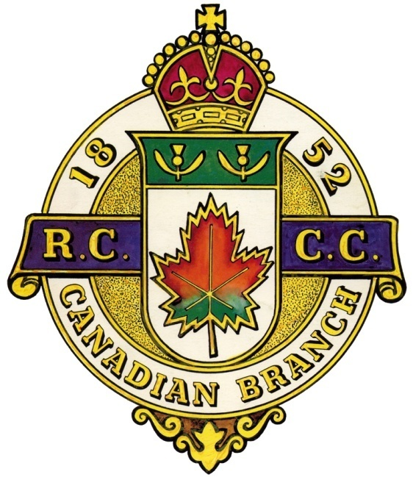
The CANADIAN BRANCH La FILIALE CANADIENNE
of the du
ROYAL CALEDONIAN CURLING CLUB
COUNCIL OF MANAGEMENT
ASSEMBLÉE DES ADMINISTRATEURS
Pointe Claire Curling Club, 250 Lanthier Ave, Pointe-Claire, Quebec
Friday, May 31, 2019 7:30 pm – Vendredi le 31 Mai 2019 1930h

AGENDA / ORDRE DU JOUR
- Call to Order / Ouverture de l’assemblée
Gerry Yuskowski, President called the meeting to order at 7:37pm
- Opening Remarks / Bienvenue
Gerry Yuskowski, President, welcomed all. It has been a successful year for the Canadian Branch. The Gordon, Governor Generals and the Quebec Challenges were good. He thanked all for their efforts.
Gerry and Brock attended the ARCM meetng Wednesday night and received the new schedule. Matthew Kennerknecht has accepted to become the new 1st Vice President. Matthew was on vacation in Scotland and sent his regrets.
- Invocation / Invocation
Gerry Yuskowski, President, provided the Invocation.
- Moment of Silence / Un moment de recueillement
Gerry Yuskowski, President, called for a moment of silence for fellow curlers who passed away during the past year.
- Notice of Meeting / Avis du convocation
It was noted that the Notice of Meeting had been duly distributed [On file as Doc#1].
- Special Guests / Invités spéciaux
No special guests were present.
- Roll Call / Presences
Gerry Yuskowski, President, called upon the attendees to present themselves and their affiliations.
Jim Mastine – Lennoxville Brock MacDonald – Lachine
Rob Kluke – North Grenville Don Robinson – Lacolle
Dave Dubois – Mount Bruno Gerry Yuskowski – Pointe Claire
Robert Dods – Pointe Claire

- Agenda / L’ordre du jour
Gerry Yuskowski, President, confirmed that everyone received a copy of the Agenda. [On file as Doc#2].
Brock and Jim added Quebec Challenge rules.
Motion to accept modified agenda/ Adoption de modifie l’ordre du jour
Motion proposed: Brock MacDonald
Seconded: Jim Mastine
Passed unanimously.
- Minutes of the last meeting (September 28, 2018)
Procès-verbaux de la dernière assemblée (le 28 Septembre 2018)
Gerry Yuskowski, President, confirmed that everyone received a copy of the Minutes for the September 28, 2018 meeting. [On file as Doc#3].
  - Motion to Accept the Minutes of the last meeting / Adoption des procès-verbaux de la dernier assemblée
Motion proposed: Robbert Kluke
Seconded: Jim Mastine
Passed unanimously.
- Business arising from the minutes
Affaires découlant des procès-verbaux
- New events and schedule – Brock to talk to Bill Woods about a “President’s Mixed” bonspiel early in the season (before Christmas) on OVCA ice.
Brock talked to Brian Moore (Utica) about a Double rink competition in a double knockout format. More work is required.
- RCCC affiliation – Still no response from RCCC. Robert to email Bill Duncan to see if he could be our agent with RCCC.
- Get RCCC ties for Canadian Branch Executives – Robert to get prcing from RCCC.
- Building Honorary Members web section – Robert to followup
Bill Stevenson to provide information.
- 1,000th Quebec Challenge - Brock to organize. Suggested Blind Bid to participate in 1,000th. Possible location – Hudson Whitlock. Potentially $200 per team, 16 teams. 2 reserved for CQ executives and OVCA executives.
- Date set as Saturday, February 2nd, 2020
- Brock to confirm Whitlock ice
- Jim and Brock to work on event.
- Correspondence/ Correspondance
None
- Regional Reports / Rapports régionaux
  - Montréal (District 1)
Brock MacDonald reported Lachine will hold a 125th bonspiel September 20 – 28. Pointe Claire CC will be holding 100th in 2021. The Branch has plaques to celebrate club milestones.
No new ARCM executives despite rumours of replacing current executives.
  - Outaouais & Ontario (District 2)
Rob Kluke was to check to see if Canadian Branch could attend OVCA AGM.
Gerry Yuskowski to send email to CQ (Marc-Andre) to meet Rob Kluke to discuss OVCA involvement with Caledonia Cup.
  - South West (District 3)
Don reported only 3 clubs left; namely Ormstown, Lacolle and Valleyfield.
  - Mauricie (District 4)
There was no representative present – no report.
  - L’Estrie (District 5)
Jim Mastine reported that Bishop’s University has offered land to move them to old golf course. Lennoxville won Quebec Governor Generals finals but lost in the GGs finals.
  - Others
No reports
    - Motion to accept the Regional Reports / Adoption des rapports régionaux
Motion proposed: Jim Mastine
Seconded: Brock MacDonald
Passed unanimously.
- Standing Committee Reports / Rapports des comités permanent
- Finance – Robert Dods
The Branch bank account balance stands at $3,330.78 as of May 31, 2019.
- Scheduling – Brock MacDonald
Governor General regionals scheduled for either November or December. Brock is working with CQ events to prevent conflicting events. Working with ARCM ice allocation. He wants to try to move GGs finals to Saturday to let CQ teams to party with Sunday to recover rather than being held on Sunday.
Still more work to do now that office is set up at home.
- Competitions – Brock MacDonald
No new events scheduled. Brock requested that the competition rules are put on the website to avoid confusion.
- Juniors – Kelso Mallette
No report.
- Gordon International – Don Robinson
Don Robinson sent in his report – see document 5. Resounding success in Eastern Townships hosting. Canada won Gordon 307 - 248. Committee could learn from their success, especially with hospitality room.
- Quebec Challenge Cup – Jim Mastine
Nine (9) successful challenges with 4 defaults. Cumberland and Brownsburg removed from participants list as per their request.
Next year’s schedule ready and up on website.
TMR defaulted 1 day before. TMR to send letter of apology to Pembroke. Does TMR stay on the list? Jim to ask TMR.
- Other
None.
    - Motion to accept the Standing Committee Reports Reports / Adoption des rapports des comités permanent
Motion proposed: Bob Dods
Seconded: Jim Mastine
Passed unanimously.
- Other Committees / Autres comités
- Honorary Life Members
Bill White’s honourary membership presentation date
- Historian
No report.
- Past Presidents
No meetings held.
Curling Quebec
No representative – no report
- Other.
No reports
    - No motion is required to accept the Other Committee Reports/Aucun movement est exige accepter les Autres Rapports de Comites
- President’s closing Remarks
Gerry Yuskowski gave his thanks for working with great strong team. He also considered it a great honour. He reminded people to think about their backup/replacement and wished the Canadian Branch continued success.
He then passed the President pin to Robert Kluke.
- New Business / Affaires nouvelles
New slate of officers:
President – Robert Kluke
1st Vice–President – Matthew Kennerknecht
2nd Vice-President – To be determined from OVCA members (Dave Brown?)
Secretary – Treasurer – Robert Dods
Director of Competitions – Brock MacDonald
Quebec Challenge Coordinator – Jim Mastine
Webmaster – Steve Mariano
Junior Coordinator – Kelso Mallette
Past President - Gerry Yuskowski

Website
We should translate website information into French, especially Home Page and sign-ups. Steve Mariano to ask Claude Renaud if he can do.
New President’s remarks
Rob Kluke, being ill-prepared, asked for our help. Our priority should be next year’s schedule.
- Next meeting / La prochaine réunion
Rob Kluke, President, proposed that the date of the next meeting will be Thursday, September 5th, 2019 at Pointe Claire Curling Club at 7:30 p.m.
- Adjournment / Fin de l’assemblée
The President then entertained a Motion to Adjourn, said motion offered by Robert Dods.
The meeting was adjourned at 9:58 pm.

